**Concordium — Transpa*rency Report №2***

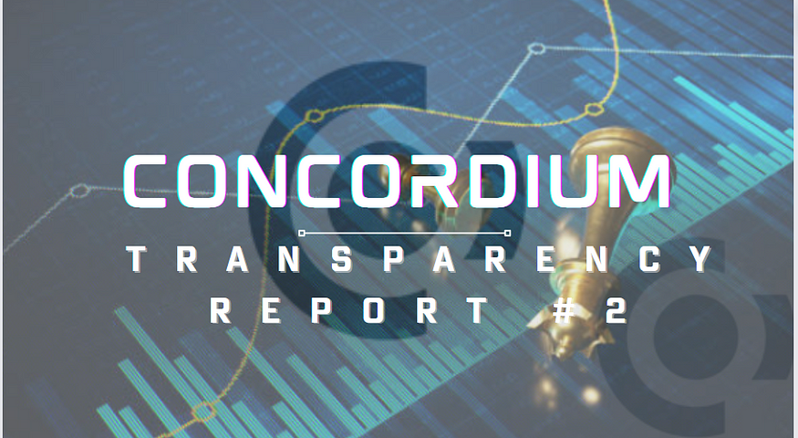

**Abstract**

Introducing Transparency Report №2, covering events in the period from July 2023 to February 2024.

Concordium outlines pivotal advancements, notably in technology, a substantial decrease in transaction fees, and heightened on-chain transaction volumes.

This document articulates management’s forward-looking projections, acknowledging inherent uncertainties. Emphasizing a steadfast commitment to blockchain decentralization, Concordium has initiated strategic measures to foster tighter integration and collaboration within its ecosystem. Anticipated milestones feature advancements in technology development and the inaugural election by CCD holders for the Concordium Governance Committee.

**Concordium Foundation holdings**

As of February 17, 2024, Concordium Foundation held approximately 4.52 billion CCDs directly on CCD-accounts, with 79% staked. This total includes around 0.72 billion CCDs pending settlement of OTC transactions and CCDs allotted to team members. After adjusting for team allocations and OTC settlement, the net CCDs held by Concordium Foundation amounted to approximately 3.80 billion, with approximately 3.59 billion staked. This represents a decrease from the adjusted CCDs held in June 2023, which was 4.05 billion.

The CCDs are distributed across 32 CCD-accounts, including eight core treasury accounts and 24 supplementary accounts serving operational purposes like transaction fee payments for specific blockchain services.

The eight core accounts are as follows:

· 49SJ6R6T9zo1C5cLVyxbwAuZC3EcDB9a78vSQYm3ZLA2y2eojM

· 47xTHwtFra1d4Mq4DYZuZYJEYrDXY34C4CGkTTzT6eiwjEczuT

· 3CbvrNVpcHpL7tyT2mhXxQwNWHiPNYEJRgp3CMgEcMyXivms6B

· 4d13WVDNKVGDUxRUb1PRQAJyTwWSVcjWS7uwZ1oqmDm5icQEPT

· 3EctbG8WaQkTqZb1NTJPAFnqmuhvW62pQbywvqb9VeyqaFZdzN

· 3ofwYFAkgV59BsHqzmiWyRmmKRB5ZzrPfbmx5nup24cE53jNX5

· 4MPJybKC9Kz7kw9KNyLHhuAEt4ZTxLsd3DBDbxtKdUiv4fXqVN

· 44bxoGippBqpgseaiYPFnYgi5J5q58bQKfpQFeGbY9DHmDPD78

On February 17, 2024, Concordium’s core accounts held 4.52 billion CCDs, with 79% (3.59 billion) staked. Operational accounts had 3.6 million CCDs, and 0.58 billion CCDs were deposited with crypto service providers. Concordium’s total CCDs, excluding pending transfers, were about 4.39 billion. On that day, the total CCDs in existence were 12.88 billion, with Concordium Foundation’s CCDs comprising 34.1%. The staked CCDs on the blockchain were 7.54 billion, of which Concordium Foundation’s staked CCDs represented 47.7%.

Concordium Foundation uses nodes primarily for staking its CCDs on core accounts, without delegation, to avoid competition with other node runners providing delegation services to CCD-holders

**Concordium Foundation rewards**

During the reporting period since the last Transparency Report, Concordium received staking rewards, totaling approximately 359 million CCDs, comprising 285 million CCDs from Finalization and Baker rewards, and 74 million CCDs from its 10% share of newly minted CCDs.

**Concordium Foundation sale of CCDs**

Concordium’s main fiat funding source is CCD sales. Pre-listing, sales occurred via TPDA agreements, shifting to OTC transactions post-listing on Bitfinex in February 2022. Since inception in 2018, approximately EUR 57 million has been raised, with no change since the last report in June 2023.

A small portion of Private Placement buyers (20 million CCDs) awaits delivery due to unverified receiving accounts. Unsettled sales of EUR 5 million (1H 2023) and EUR 0.1 million (2H 2023) are planned for settlement in 1H 2024 upon Concordium Foundation’s Swiss SRO membership activation. While CCD sales are expected to continue as the primary fiat source, the settlement of committed sales is not crucial for Concordium’s financial stability. The Foundation has secured funding commitments to ensure operational and financial stability.

**Concordium cap-table and CCD lock-up commitments**

For the 2021 Private Placement rounds, Concordium Foundation instituted a CCD lock-up policy, determining the release timing for CCDs received after the Token Generating Event. The corresponding 2021 cap table, with updated lock-up amounts for CCD holders, is provided below:

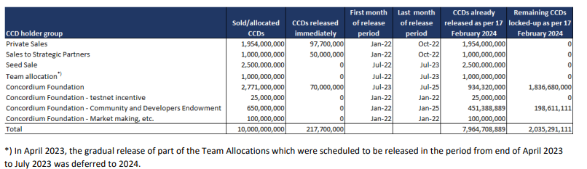

At the Token Generating Event in June 2021, Concordium Foundation held 3.546 billion CCDs. As of February 17, 2024, they have 2.04 billion CCDs under lock-up commitments until July 2025, a decrease from the previous report. The team’s 10% allocation from the 2021 cap table was 1.00 billion CCDs, with 0.19 billion CCDs remaining. Private Sales, Strategic Partner, and Seed buyer allocations, totaling 5.45 billion CCDs, have been distributed, and lock-up periods have expired.

**CCD holdings of Concordium Seed Founders, advisors, and team**

In 2018, Founders and Seed investors acquired 25% of the Genesis Block, totaling 2.5 billion CCDs. By early 2019, COBRA scientists and advisors received 0.19 billion CCDs. As of June 2023, the total on these accounts was 3.32 billion CCDs, and by February 17, 2024, it increased to 3.40 billion CCDs, up by approximately 80 million CCDs. This net increase results from fewer CCDs being transferred out than received through rewards or acquisitions.

Management acknowledges CCD sales by team members to cover tax obligations, with uncertainty about the extent. For Danish team members, the applicable tax rate is typically around 50%. Currently, management is exploring alternative distribution models for remaining CCDs in existing and future team incentive programs.

**Changes to the regulatory set-up regarding sale of CCDs**

Concordium Foundation, as a payment token issuer (CCD), is categorized as a financial intermediary under Swiss regulations. It operates under the supervision of a Swiss Self-Regulatory Organization (SRO). In 2023, the Foundation opted to become a direct member of a Swiss SRO, terminating its engagement with an external KYC/AML provider. During the SRO membership activation period, Concordium Foundation won’t receive additional funds from CCD sales.

**Tokenomics highlights**

As of February 18, 2024, Concordium Blockchain operates on approximately 200 nodes, with fluctuations but consistently above 150 nodes since the last report. Concordium Foundation is staking CCDs with 9 nodes. Tokenomics parameters are outlined in the tables below, comparing current values with those in the previous Transparency Report.

· Current CCD growth rate: 8% (10%).

· Average Block Time, last 30 days: 2.2 seconds (10.1 seconds).

· Average Finalisation Time last 30 days: 4.3 seconds (11.9 seconds).

· Number of delegators: 1,860 (1.610).

· Number of validators: 176 (191).

· Average daily number of transactions last 30 days: 118,996 (28,932).

· Number of transactions since inception: 22.2 million

· Average daily number of blocks in the last 30 days: 40,151 (8,537).

· Number of newly minted CCDs since inception: 2.88 billion (2.15 billion).

· Number of CCDs paid as block rewards to validators since inception: 2.55 billion (1.82 billion).

Concordium previously boosted transaction levels by supporting services, contributing to over 95% of transactions in 2023. These services, backed by Concordium, maintain a minimum transaction level and facilitate blockchain performance monitoring. In 2024, as use case-driven transactions surge, Concordium intends to reduce its support for transactions, aligning with the rise of DeFi applications and other use cases.

**Concordium’s Technology & Product Development**

Concordium’s product vision centers on four key themes listed below, emphasizing decentralization as the primary focus for 2024. Increased attention will be given to user experience, collaborative efforts with the community, and ensuring value delivery to support decentralization.

1. Doubling down our effort scaling up the Developer Community

2. Implementing decentralization of governance bringing our community closer

3. Lowering the onboarding hurdle for Web2 companies to use blockchain as their infrastructure.

4. Bringing great user experience to our wallets, making onboarding extremely easy.

The following section lists the products and areas Concordium’s Product and Engineering teams strive to build out in line with the 4 focus areas.

**The Blockchain & SDKs**

**Scalability:** Released Concordium BFT in September 2023, making it one of the fastest blockchains globally.

**Onboarding**: Launching Track and Trace and Real-World Assets frameworks in Q1 2024 for quicker Use Case implementation.

**SDKs**: Improved functionality and ease of onboarding with additional features in Q3 and Q4 2023.

**Tooling**: Released Cargo-Concordium, VScode extensions, and Smart Contract libraries for enhanced usability.

**NRG cost**: Reduced transaction cost by 100X on February 7, 2024, with further optimization plans.

**Agora Marketplace**: Successfully expanded capabilities with the Agora Impact Market in Q4 2023, supporting carbon credit tokenization and trading.

**Community**

**Governance:**Implementing Governance voting by June 2024, we aim to develop a unique platform for nuanced voting scenarios, going beyond “one token, one vote.” Strengthening decentralized Governance, we’re committed to closer collaboration with our community.

**Developer Community:**With increased focus from January 2024, we’ve appointed a Senior Developer Community Manager and a Developer Relations Engineer in February. Developing the Developer Community is vital for Concordium’s success, encouraging developers to build on our platform, crucial for use case adoption and decentralization. The community serves as an extension of Concordium’s core developer team, with the primary goal of attracting more developers to build on Concordium.

**Identity**

Concordium’s Identity Layer, a key Unique Selling Proposition (USP), will continue to evolve, facilitating businesses in building applications leveraging the built -in ID features and the Concordium wallet.

**National Identities:**Implemented support for Danish MitID in Q4 2023 enables obtaining a Concordium identity with a few smartphone swipes. A similar feature is supported for Finland.

**Web3ID:**Released in September 2023, Version 3.0 of Concordium’s ID layer, known as “Web3ID,” aligns with W3C standards for self-sovereign identity. Web3ID allows any company to issue credentials about a person, and users can verify information through zero-knowledge proofs. Future efforts include simplifying business onboarding, providing machine IDs, facilitating issuer status for businesses, and enabling verifiers to check zero-knowledge proofs.

**CompanyID:**Enhanced UI and onboarding for companies to establish their identity, with further improvements planned in Q1 2024 to enable ID for Virtual Assets Service Provider (VASP) companies.

**Wallets**

Concordium wallets provide access to blockchain functionality, catering to iOS, Android, Chromium browsers, and desktop users on OSX, Windows, and Linux. The focus for 2023 and continuing into 2024 is to enhance accessibility for external wallets, expanding user reach.

**Mobile Wallet:**Released in Q1 2024, the updated CryptoX wallet prioritizes a smoother onboarding experience. Users are introduced to a home page showcasing use cases and Web3 features, enhancing user engagement. Transaction initiation requires user identification, improving the overall experience.

**Desktop Wallet:**Tailored for institutional users and Concordium’s Governance Committee, the Desktop wallet maintains support for these groups but is not designed for dApp use.

**External Wallets:**Ongoing efforts include extending Wallet SDKs to simplify integration with 3rd party wallets. Browser and Android wallet SDKs were released in January 2024, with the iOS wallet SDK set for release in March 2024. This initiative aims to broaden Concordium’s audience, increase visibility, and enhance user accessibility.

**Explorer:** CCDScan.io, Concordium’s blockchain explorer, caters to developers and end-users, providing specialized support for Validators, Stakers, Developers, Traders, CCD-owners, and Data Analysts.

**Smart Contracts:**CCDScan updates include a portal facilitating search, reading, and viewing of smart contracts. Additionally, new circulation supply endpoints for CoinMarketCap and CoinGecko, along with TVL endpoints, have been released.

**DeFi Ecosystem:** Concordium’s DeFi ecosystem support, fueled by the unique Identity Layer, expands with key features:

**KYC-as-a-Service:**Web3ID enables service providers to issue KYC-verified credentials, easing KYC-friction. Partnership with Muinmos enhances this service.

**Bridge:**Boosty Labs integrates Concordium into Tricorn crosschain bridge service, enabling bidirectional transfers with Ethereum. Expected release in Q1 2024.

**Oracle:**Umbrella’s oracle, launched in Q4 2023 on Concordium, adds data feeds based on community feedback.

**Stablecoins:**Membrane Finance introduces EUROe stablecoin in December 2023.Concordex supports various bridged tokens, including WUSDC, WUSD, WBTC, WETH, WDAI.

**Launchpad:**Concorpad, the first launchpad, goes live in December 2023, offering ICO capabilities and key features for project launches.

**Indexer:**A released Indexer simplifies Concordium development, allowing quick lookups of key chain data and easy local chain launches with one click.

**Industry Infrastructure development**

Concordium is expanding its crypto and blockchain infrastructure tools to enhance CCD-holder capabilities. Copper.co, the first institutional custodian in the Concordium ecosystem, successfully integrated CCD. Other custodians are interested in integrating CCD and Concordium’s smart contract standard (CIS2). Concordium aims to improve institutional and self-custody solutions. Various staking services are available to CCD holders, with growing interest. Major providers like Figment.io, Luganodes, Northstake, Amdax, and Myrmidon Staking support CCD staking. Concordium simplifies integration by providing documentation and support, especially focusing on centralised exchanges.

Concordium supports initiatives for bridging CCD and CIS2-based tokens to other networks and vice versa.

**Concordium’s Commercial Activities & Grant Program**

**Commercial activities**

Concordium’s commercial activities surged in the last eight months due to expanded infrastructure, key partnerships, low-code framework development, and increased overall chain activity, setting the stage for a promising year ahead.

**Essential infrastructure developments on Concordium**

Concordex, launched in H2 2023 by Tacans AG is the first decentralized exchange on Concordium blockchain, experiencing rising transactions and liquidity, reaching $1 million in volume. Key additions include the first ERC-20 bridge (Arabella) and ongoing development of the multi-chain bridge (Tricorn) by Boosty Labs. In January 2024, Umbrella Network integrated the first oracle service, and Subquery became the inaugural blockchain indexing solution. Concorpad, the first token launchpad, emerged in H2 2023, with ongoing assessments of Token Generating Events. Membrane Finance introduced EUROe, the first native stablecoin on Concordium, available for trading on Concordex, signaling its growing significance in stable financial interactions.

**Key partnerships and developments**

Concordium’s decentralized shift involves strategic investments in partnerships. Corporate collaborators leverage Concordium’s expertise for solutions addressing business challenges. Projects explore zero knowledge technology, verifiable credentials, and ID-layer for accountability. Open-source elements contribute to cryptographic innovation. The partnership with Blockchain Founders Group includes an 8-week accelerator supporting startups on Concordium, offering workshops, mentoring, and potential funding up to €120,000. The program is open for submissions, with promising initial applicants.

In 2023, we partnered with Hitachi Solutions, concluding the year. Our collaborative focus is proof of technology on the Concordium blockchain, aiming to develop a Web3 wallet. The primary goal is to enhance usability by integrating biometric electronic signatures. Hitachi’s Public Biometric Infrastructure (PBI) platform plays a crucial role, combining biometric authentication with PKI digital signature technology.

**Low-Code frameworks**

Technical partners and Web3 developer houses contribute to new infrastructure and support structures, notably in the development of low-code frameworks. An example is the Agora NFT Marketplace’s latest iteration, AgoraIMPACT, an open-source low-code framework launched in Q3 2023. It supports ESG projects for seamless and trustworthy carbon offsetting. Concordium’s tech and science team reviewed Agora-RWA, available as an open-source framework since February 2024, aimed at expediting development and reducing costs for projects tokenizing Real World Assets. Its customizable architecture prioritizes safety and efficiency, featuring compliance-ready customer lifecycle management, access controls, commissioning, shielding, sponsoring of transactions, and zero knowledge proofs for verifiable credentials and portable KYC/AML checks tailored to specific use cases.

**Overall increase in activity**

As the Concordium ecosystem expands, supporting participants is crucial. The Developer Endowment Pool aids projects with tokens, boosting user engagement and transactions, notably from key contributors like AesirX and Digital Social ID. With more projects expected, the pool is vital for blockchain activity growth. Increased GitHub activity signals growing use case interest and a dynamic community. Ongoing developer support is anticipated, evidenced by the new ambassador program, highlighting a commitment to community inclusion and engagement.

**Key focus areas for 2024**

The RWA vertical’s next step involves the commercial team and ecosystem partners supporting Concordium’s blockchain and smart contract technology for use cases. The introduction of the Tricorn bridge facilitates asset flow, connecting Concordium with other ecosystems and enabling token wrapping. This enhances accessibility and lowers entry barriers. A focus on increasing transaction volume drives innovation and growth, with AesirX and Digital Social ID showcasing successful collaborations. The Concordium grant program has been revamped for a more structured and transparent application, review, and decision process. Ongoing efforts prioritize fostering innovation and growth within the Concordium ecosystem.

**Concordium Grant Program**

Concordium, in collaboration with Seier Capital A/S, manages the Concordium Grant Program to support innovative projects within its ecosystem. The program offers expert guidance and financial backing for startups and enterprises utilizing Concordium’s technology. In the latter half of 2023, it supported over 15 projects, expanding the ecosystem in diverse directions.

Projects like MeProtocol and SharingClub contribute to Tokenized Loyalty Programs, enhancing customer engagement on the Concordium blockchain. In generative AI dApps, initiatives like Orpiva, 2021.ai, and Signa-X pioneer innovative applications to redefine user experiences. Golisto reshapes asset representation and trading on the blockchain, ensuring a secure foundation for tangible asset tokenization.

The grant program introduced key blockchain infrastructure, including Web23’s naming service and Subquery, the first indexing service for Concordium, enhancing data accessibility.

Additionally, the program backed groundbreaking initiatives such as IBEXUS’s autonomous agreements, VeritaTrust’s platform addressing fake reviews, and TechFiesta’s web3-focused hackathon platform. Edubuk’s diploma verification tool and Gonana Farm, a web3-enabled marketplace, were also introduced on Concordium.

Aligned with Concordium’s commitment to impactful innovation, the grant program supports projects addressing real value across various industries.

**Marketing activities**

The marketing highlights for the second half of 2023 and the beginning of 2024 include the following:

· Rebranding of the Concordium blockchain resulting in a new website, new visual identity, and mission & vision statements.

· A major boost in our marketing spends, prioritization and execution.

· Higher engagement on social media, better share of voice positioning in Web3 and significant community growth.

· Decentralization and marketing.

Concordium significantly increased marketing efforts in recent months, focusing on rebranding to establish itself as a leading Layer-1 project in the Web3 space. The rebranding includes a new website, visual identity, mission, and vision, emphasizing decentralization and embedding identity at the protocol layer for privacy and accountability.

The marketing team has highlighted prominent use cases, fostering exposure and business opportunities, particularly in areas like ESG. Collaborations with influencers, such as digital identity expert Bianca Lopes, resulted in successful events, like the LinkedIn event with 1331 sign-ups, 560 leads, and 100 ongoing conversations.

LinkedIn growth exceeded 25%, and a significant partnership with Hitachi Solutions was announced, focusing on proof of technology to build a Web3 wallet with biometric electronic signatures using Hitachi’s PBI platform.

Media placements in publications like Cointelegraph, Decrypt, DeFi Lama, Blockworks, Biometric Update, and Benzinga have established Concordium’s thought leadership, creating awareness, and attracting high-quality leads.

Concordium has notably increased its share of voice and media coverage compared to other Layer-1 competitors, achieving a 25.4% share of voice in media coverage during September. The successful DeFi report, highlighting Concordium as the most regulation-ready blockchain for dApps, generated 500 leads, with 60% from Google ads and 40% from LinkedIn ads.

Social media engagement has grown across platforms: 9% on Twitter, 25% on LinkedIn, 43% on Discord, and 28% on Telegram. YouTube subscribers increased by 25%, with an average livestreaming viewership of 2.7K views, attributed to optimized content presentation.

Concordium’s community expansion efforts, like the Galxe and Bit2Me campaigns, attracted new Web3 crypto-native members, generating significant numbers in Discord engagement, media mentions, reach, wallet downloads, and account creations.

The CCD token listing on Bit2Me targeted the Hispanic market, tapping into approximately 500,000 active users. The focus for 2024 includes decentralization, awareness creation, and co-marketing efforts to amplify use cases. Partnerships with platforms like Giga Corp aim to exponentially grow the Concordium community, and collaborations with PR partners, influencers, and paid media will continue.

Our ambassador program is crucial for community growth and decentralization, empowering members to actively engage. Coupled with a digital asset management system, community members can create and share content with Web3 enthusiasts, enhancing Concordium’s presence. The DAM system, evolving from Concordium’s media kit, serves as a user-friendly platform with creative assets.

Finally, building on lessons from the past year, we aim to set new standards in the blockchain space, increasing awareness among crypto natives and developers. This involves strategic event participation, targeted PR efforts, space establishment, hackathons, key partnerships, and more.

**Concordium Governance**

Concordium’s governance consists of two main elements: Corporate Governance, overseeing decision-making and responsibilities within the Concordium Group, and Blockchain Governance, handling decision-making and responsibilities within the Concordium Blockchain.

**Concordium Corporate Governance**

The Concordium Foundation, guided by its Public Deed, aims to oversee the development of the Concordium blockchain within the principles outlined in its purpose. The Foundation operates under the supervision of Swiss authorities. Bjørn Krog Andersen resigned from the Board in January 2024 due to other business engagements.

Hereafter, the members of the Concordium Board of Directors are the following:

· Lars Seier Christensen, chairman since inception, Swiss resident, Danish nationality

· Simone Monnerat, board member since inception, attorney at law, Swiss resident, Swiss nationality

· Ueli Maurer, board member since inception, professor at ETH, Swiss resident, Swiss nationality

· Ian Zhang, board member since October 2021, Swedish resident, Chinese nationality

Since the previous Transparency Report in June 2023, the Concordium Foundation Board conducted three meetings in September 2023, December 2023, and January 2024. The Board follows an annual plan, addressing specific topics aligned with internal policies and regulatory requirements, including risk analysis and financial planning.

**Concordium Blockchain Governance**

The Concordium Board has established a Governance Committee, currently comprising five members. This committee evaluates and implements parameter changes, oversees tokenomics, and develops the governance framework for approval by the Foundation Board.

Concordium is committed to a gradual decentralization of blockchain governance, transitioning to a hybrid form of representative and direct democracy. CCD holders will increasingly participate in shaping priorities, electing Governance Committee members, proposing candidates, voting on proposals, and formulating their own suggestions. The Foundation Board ensures adherence to Concordium principles. The next decentralization step occurs in June 2024, with two community-elected members joining the Governance Committee.

**Concordium’s strategy for decentralization**

The Board of Concordium Foundation has adopted a strategy for governance decentralization, which include the following steps:

**Step 1. Preparation phase from Mainnet launch in 2021 to 2024.**

The Board of Concordium Foundation appoints all five members to the Governance Committee.

**Step 2. Gradual decentralization: June 2024 (Mainnet +3 years)**

CCD-holders use electronic voting to appoint two new members to the Governance Committee from a Board-proposed candidate list, expanding the Committee from five to seven members. Currently, two out of seven Governance Committee members are appointed by CCD holders.

**Step 3. Further decentralization: June 2025 (Mainnet +4 years)**

CCD holders elect two new members to the Governance Committee through electronic voting, increasing the Committee’s size from seven to nine members. CCD holders propose all candidates for the Governance Committee. Currently, four out of nine Governance Committee members are appointed by CCD holders. Token holders can vote on specific technical proposals, with a governance framework defining eligible proposals and required quorums for acceptance.

**Step 4. Further decentralization: June 2026 (Mainnet +5 years)**

The Governance Committee, currently consisting of nine members, has three seats up for (re)electionannually. In 2026, three seats initially appointed by the Board of Concordium Foundation will be open for election, leaving CCD holders to appoint five out of nine members. CCD token holders can propose changes to parameters or elements of the tokenomics.

**Step 5. Further Decentralization: June 2027 (Mainnet + 6 years)**

CCD holders will appoint all Governance Committee members and can modify aspects of the governance framework. This grants CCD holders an increased role in shaping and overseeing Concordium’s development. The Governance Committee’s mandate will be refined based on experience gained in preceding steps.

**Composition of the Governance Committee**

Initial composition in 2021 of the Governance Committee:

· Lone Fønss Schrøder, Concordium Group CEO.

· Jørgen Hauglund, Concordium Group CFO.

· Beni Issembert, Concordium Group CMO.

· Torben Pryds Pedersen, Concordium Group CTO.

**Log of changes to the Governance Committee**

· June 2022: Resigned member: Torben Pryds Pedersen.

· June 2022: Resigned member: Beni Issembert.

· June 2022: New member: Michael Jackson.

· June 2022: New member: Kåre Kjelstrøm.

· June 2022: New member: Christopher Portmann.

· March 2023: Resigned member: Lone Fønss Schrøder.

· March 2023: New member: Torben Pryds Pedersen.

· October 2023: Resigned member: Kåre Kjelstrøm.

· October 2023: New member: Nibras Stiebar-Bang

**The current members of the Governance Committee**

· Michael Jackson, an independent member of the Concordium Advisory Board, Luxembourg resident, British nationality.

· Jørgen Hauglund, Concordium Group CFO, Danish resident, Danish nationality.

· Nibras Stiebar-Bang, Concordium Group CTO, Swedish resident, Swedish nationality.

· Torben Pryds Pedersen, Special Advisor to Concordium’s Commercial Team, former CTO of Concordium Group, Danish resident, Danish nationality.

· Christopher Portmann, Scientist with Concordium’s science team, Swiss resident, Swiss nationality.

**New Governance Committee decisions since June 2023**

**Decision GP-010, August 2023**

· Protocol update to increase the maximum output of the Concordium blockchain.

· Changes the consensus protocol from an existing two-layer design to a new ConcordiumBFT consensus.

· Adds better support for sponsored transactions.

· Other fixes and improvements.

**Decision GP-011, November 2023**

· Parameter updates to simplify the tokenomics, aligning with industry standards, and promoting a vibrant and dynamic staking ecosystem

· Finalization rewards are removed, and the corresponding minted CCDs are distributed as part of the block rewards.

· The maximum pool size is bounded by 5% of the pool stake.

· The ratio between the pool stake and validator stake is at most 6.

· The stake needed to set up a validator is increased to 500,000 CCDs.

· Passive commissions are increased to 25%.

· Pool commissions can be chosen freely by the validator running the pool.

· The cool-down for delegators is set to the same value as for validators, namely 3 weeks.

· The mint rate is decreased to 8% p.a.

**Decision GP-012, January 2024**

· Parameter update to reduce the cost of transactions with the goal of insuring competitive transaction fees for both simple and complex transactions

· The cost in EUR of all transactions is reduced by a factor of 100.

· The cost for simple transactions is planned to increase to the past level of slightly below in connection with a later implementation of a new pricing mechanism that will ensure competitive fees for all transactions.

**Earlier GC decisions already included in the June 2023 Transparency Report**

· GP-001 (Sep 2021): Adjust CCD/EUR exchange rate to match Private Placement pricing.

· GP-002 (Oct 2021): Introduce meta text (memo) for CCD transactions.

· GP-003 (Jan 2022): Include Digital Trust Solutions as an identity provider.

· GP-004 (Jan 2022): Support multiple addresses for the same account.

· GP-005 (Jan 2022): Incorporate keys for automatic CCD/EUR rate updates.

· GP-006 (Feb 2022): Modify rules for automatic EUR-stable transaction fee updates.

· GP-007 (Jun 2022): Set initial parameters for delegation, update minting rewards allocation, and adjust baker and delegation cooldown period.

· GP-008 (Jun 2022): Introduce delegation support, new smart contracts, synchronous calls, and cryptographic primitives.

· GP-009 (Dec 2022): Update protocol to support upgradable smart contracts, allow smart contracts to query additional data, and improve account storage efficiency.

**Concordium Corporate Structure**

The Corporate structure of the Concordium Group is shown the diagram below:

· Concordium Foundation

· Concordium AG

· Concordium Research ApS

· Concordium Software ApS

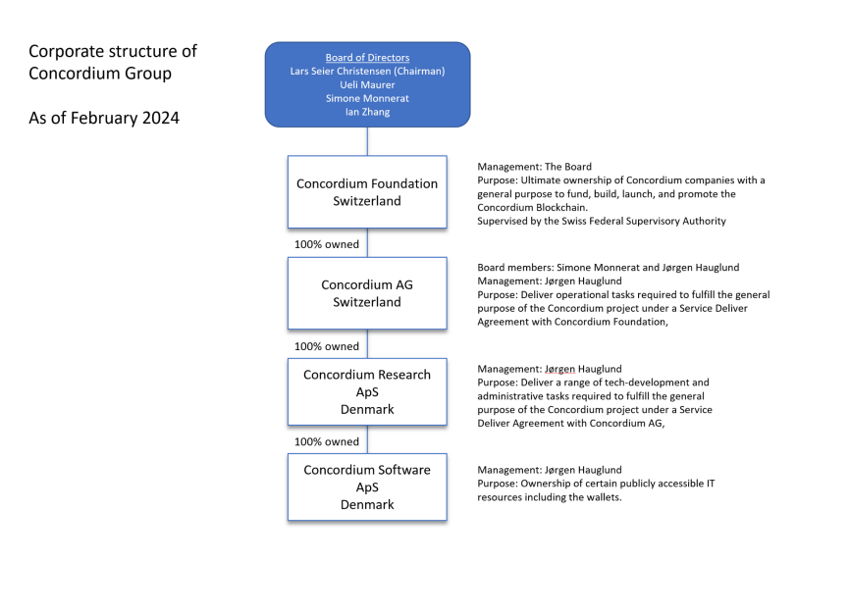

Finally, it is important to note that Inactive Concordium Reg DeFi Lab AG has been removed from the group chart since Transparency Report №1.